Riemerella Infection in Ducks
Sara Perez – Poultry Specialist Team, Minster Veterinary Practice. Consultants for Cherry Valley Farms Ltd.
 | Minster Veterinary Practice is one of the oldest in the UK and was established in 1900. It employs 44 veterinarians and over 100 support staff, working from offices and laboratories that include the central office in York and an out-station at Nottingham University. The Practice are the veterinary consultants for a leading duck integration and the Cherry Valley operations in UK, supporting the international primary breeding and genetics program.  Sara Perez qualified as Veterinarian from Barcelona University, Spain and gained a Master in Science at the University of Bristol, UK and a Certificate in Poultry Medicine and Production from the Royal College of Veterinary Surgeons in London. She works as a consultant to the poultry industry in UK and Europe, dealing with flock health and production management in chickens, turkeys and ducks.  Sara represents the Poultry Veterinarians at National Level for the British Veterinary Association. She has written numerous articles in poultry publications and actively participates in poultry legislative and codes of practice consultations.

Riemer first described an epizootic septicaemia of domestic fowl in 1904 and Riemerella anatipestifer infection, which is also known as new duck disease, duck septicaemia or infectious serositis, is a septicaemic disease of growing ducks that has worldwide importance.
Over the years, Reimerella anatipestifer has been known by different names and this has led to confusion surrounding the incidence and treatment of the Reimerellosis. The bacterium shares phenotypic characteristics with Flavobacter spp. and has been historically and incorrectly known as Moraxella anatipestifer and Pasteurella anatipestifer due to their similar ecology and morphological/cultural characteristics. Its current classification as Reimerella anatipestifer was established by Segers and his colleagues, working in Belgium in 1993.
Riermerellosis normally affects ducklings aged between 2 and 6 weeks and sometimes up to 8 weeks of age. The bacterium is most commonly transmitted by hatching eggs, but there may be lateral spread through the respiratory route. Outbreaks of the disease that lead to mortality are usually related to poor husbandry or environmental stress, for example; moving the birds from one farm to another or a breakdown in the ventilation equipment. Exposure to Riemerella does not normally lead to clinical disease in unstressed birds, but mortality can exceed 70% in severe cases.
Signs and symptoms may appear 3 days after a stressful event and in some cases, the first sign will be a spike in mortality from an apparently healthy flock. Chronic symptoms include nervous signs like head shaking, walking with the head drawn into the body and difficulty walking. Affected ducks may be found on their backs, unable to right themselves.
Riemerellosis is a bacterial septicaemia and the lesions in affected birds may resemble streptococcus or E.coli infections. Congested lungs, an enlarged and pinkish liver, and an enlarged and purple spleen are typical lesions of the acute form of the disease. In such cases, the vent may be stained a greenish colour and the beak may be congested, but the carcass is often well fleshed. In its less-acute or chronic form the disease commonly causes sinusitis and may result in pericarditis, perihepatitis and airsacculitis, particularly in the abdominal airsacs. As the disease progresses the posterior airsacs may become involved and females may suffer salpingitis.
In addition to this generalised septicaemia, Riemerellosis may be associated with thickening of the skin, especially of the ventral abdomen. Barely noticeable tracks of caseous pus can be found between the skin and the muscles, but it is unusual to find significant cellulitis.
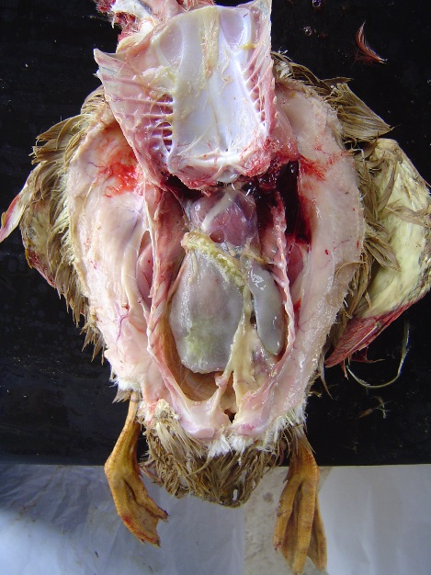 | 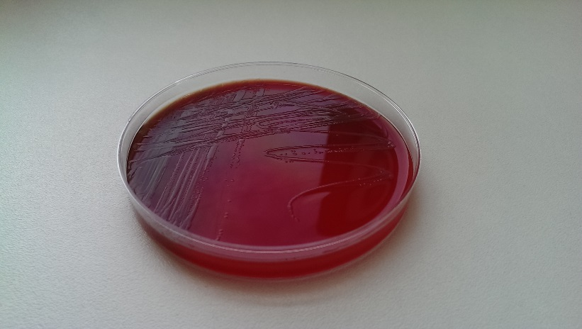  Pictures showing typical RA septicaemia (left) and RA cultured on Blood Agar (above).

The infection normally gets complicated with other secondary pathogens, such as E.coli. Therefore, in routine cultures the overgrowth of E.coli can make the isolation and identification of Riemerella difficult. To confirm a diagnosis it is necessary to culture tissue samples taken from the brain or heart where it is unlikely to find E.coli. . R.a. will grow on blood enriched agar, but the plates must be incubated at 37 degC for at least 48 hours and sometimes up to 72 hours is needed before the small, greyish colonies become visible. Increasing the CO2 level to 5% will encourage growth and aid identification. 15 serotypes of R.a. have been identified that vary considerably in morphology and pathogenicity, but there are thought to be many and various field strains.
Other diseases that may cause similar signs in ducklings that should be considered as differential diagnoses include; E-coli and Streptococcal septicaemia, duck viral hepatitis, duck viral enteritis, coccidiosis and mycotoxicosis.
Riemerellosis can be very successful treated by individual intramuscular antibiotic injection, but such treatment is very expensive to administer and not feasible in large flocks. Commercial flocks can be treated with antibiotic in the drinking water (e.g., sulphadimidine at 30-60 g/100 birds/day for 3 days) or in the feed (e.g., sulpha-quinoxolone at 250-350 ppm for 5 days), but prevention is better than cure.
Vaccination against Riemerellosis is possible using live sprayed or killed injectable products. Standardised vaccines are available, but they rely on reference strains of R.a. and may not give good protection in all situations. Best practice is to produce a vaccine using local isolates (autogenous vaccines), however, R.a. is not easy to culture and it will take time and patience to develop a formulation that works.
The key to controlling the disease without the cost or inconvenience of treating the flock is to manage it properly and avoid stressing the ducks. If it is necessary to move the birds to different accommodation, they must be properly acclimatised beforehand. Ducks that are kept at a low stocking rate and in good environmental conditions are less susceptible to the disease. Farms that are isolated, properly cleaned and practice all-in-all-out management have a low incidence of disease.
Following the principles above Riemerellosis has not been diagnosed on Cherry Valley’s farms in UK for a number of years. Key elements in the disease control strategy include:
- Effective egg washing to control spread of the disease through the egg route and prevent vertical transmission;
- All-in-all-out flock placement and high standards of cleaning and disinfection to control horizontal spread between succeeding flocks;
- Duck friendly management, including appropriate stocking density and high standards of environmental control, to minimise stress on the animals.
- Regular veterinary visits, to assess the health status of the flock.

